 

INSTITUTE FOR ADVANCED COMPUTING AND

SOFTWARE DEVELOPMENT

AKURDI, PUNE

Documentation On

**“Fine Living”**

E-DAC MAY 2021

*Submitted By:*

**Group No: 10**

**Ankita Singh 1015**

**Akshay Shimpi 1011**

**Mr. Prashant Karhale Mr. Milind Arjun**

**Centre Coordinator Project Guide**

# Table of Contents

1. Introduction 1

Document Purpose 2

Problem Statement 2

Product Scope 2

Aim & Objectives 2

1. Overall Description 3

Product Perspective 3

Benefits of System 3

User and Characteristics 3

Operating Environment 3

Design and Implementation Constraints 3

1. Requirements Specification 4

External Interface Requirements 4

3.3 Non-Functional Requirements 12

1. System Diagram 11

Activity Diagram 11

Data Flow Diagram 13

Class Diagram 15

Use Case Diagram 16

ER Diagram 16

1. Table Structure 17

User 17

Services 18

1. Conclusion 19

Future Scope 19

1. References 20

# Introduction

Fine Living.com is an e-commerce website allows consumers to electronically provide goods and services with no barriers of time or distance. Electronic commerce has expanded rapidly over the past five years and is predicted to continue at this rate, or even accelerate. There is almost no area of service Fine Living does not cover. Having nine categories present in the app – massage and fitness, appliance repair, home cleaning, moving homes, beauty and spa, painting and renovation, weddings and events, academic tutors, business and taxes – everything here is just one click away. Payment options - COD, EMI, Credit card, Debit card & more.

## Document Purpose

The purpose of the document is to collect and analyze all assorted ideas that have come up to define the system, its requirements with respect to consumers. The purpose of this SRS document is to provide a detailed overview of our software service, its parameters and goals. Developing an online platform is a job that requires equal share of technological expertise and sound decision making. Principally built on MERN stack, this website makes home services experience as satisfying as in a real store. Programming engineers make it sure that the site is high on responsiveness and low on technical errors, which is the most favorable selling point of this online platform.

Enhance Business Processes:

To be able to use internet technology to project to the global world instead of limiting their services to their local domain alone, thus increase their return on investment (ROI).

Fine Living Services:

A platform through which user can order household services and seller can ship or provide those services to user.

## Problem Statement

Existing system for household service is based on our traditional way of calling individual person or people for any kind of service if it is plumber, electrician, AC repair, etc. During the pandemic situation of June 2020 people had problems in handling any of these issues due to unavailability of skilled professionals. Hence this system is proposed to overcome the flaws of the existing system and bridging the gap between consumer or user and service provider and provide hassle-free services.

## Product Scope

E-commerce is a term for any type of business, or commercial transaction that involves the transfer of information across the Internet. It covers a range of different types of businesses, from consumer based retail sites, through auction or music sites, to business exchanges trading goods and services between corporations. It is currently one of the most important aspects of the Internet to emerge.

* Household Services: This includes study on how the daily required services can be provided to consumer and also providing employable opportunities to providers.
* MERN Stack Technology used for the development of the application.
* General customers as well as the sellers will be able to use the system effectively.
* Web-platform means that the system will be available for access 24/7 except when there is a temporary server issue which is expected to be minimal.

## Aims & Objectives

Specific goals are: -

* To produce a web-based system that allows the consumer to order or request any type of services at ease of their house.
* To ease service providers by providing different functionalities to it.

# Overall Description

## Product Perspective:

2.1.1 Existing system function:

Existing system for household service is based on our traditional way of calling individual person or people for any kind of service if it is plumber, electrician, AC repair, etc. During the pandemic situation of June 2020 people had problems in handling any of these issues due to unavailability of skilled professionals. Hence this system is proposed to overcome the flaws of the existing system and bridging the gap between consumer or user and service provider and provide hassle-free services.

* **III. PROPOSED SYSTEM**

Fine Living’s online website based e-commerce is an outstanding way of bringing Sellers and customers on an online platform to make purchase in a secured and efficient manner irrespective of distance between the two. The service is one stop for many services online. Fine Living offers daily recommendations for discounts and offers on services based on their category

* Provide a simple interface and platform to ease the process of buying as well as selling services online
* Include smooth functionality and efficiency that adds to buyers’ confidence.
* Appropriate space is dedicated to its Offers zone and deal of the day that fetches adequate attention of users.
* Fine Living keeps a constant focus on new category creation and expansion of services.
* Ads and promotion activities motivate shoppers to buy online.
* Tracking feature of orders and pending deliveries for both sellers and buyers.
* Notifying order and delivery reports to customers and sellers.

## Benefits of System

* **Customer -** He or she is a verified user of website who is intended to buy a service from the seller via the Fine Living platform. The customer must have a username and password to make a purchase. The person is regularly updated and fed with latest offers and discounts according their interest.
* **Seller -** He or she is a verified person who is allowed to sell items over the platform. Seller’s details are stored on database and all the services are listed under him that he is ready to sell or are available. He is responsible to set services details, price, and quantity.
* **Administrator -** He or she is responsible for monitoring functions and procedures on platform. Administrator is responsible to provide valid information of a purchase to the concerned authority in case of any dispute between the customer and seller or in case of exchange.

## Users and Characteristics:

* + Notifications
  + [Contact Us](https://www.makemytrip.com/support/contact_us.html)
  + [User Agreement](https://www.makemytrip.com/legal/user_agreement.html)
  + Select the operator
  + [Make A Payment](https://payments.makemytrip.com/easypay/)
  + [Submit Account Details](https://support.makemytrip.com/customersupports.aspx?actiontype=SUBMITWIRETRANSFER)
  + [Payment Security](https://www.makemytrip.com/legal/payment_security.html)
  + Privacy Policy

## Operating Environment:

|  |  |  |
| --- | --- | --- |
| **Particulars** | **Client System** | **Server System** |
| **Operating System** | Windows/Linux/Android/iOS | Linux |
| **Processor** | Intel or AMD | Intel or AMD |
| **Hard Disk** | 1 GB | 1 TB |
| **RAM** | 256 | 8GB |

## Design and Implementation Constraints:

* The customer and seller must have basic knowledge of computers and English language.
* Each User must have a User ID and password.
* Each Seller must have Seller ID and password.
* There must be an Administrator.
* Internet connection is a must.
* Proper browsers should be installed in the user’s system

# Specific Requirement

## External Interface Requirements:

User Interfaces:

* + All the users will see the same page when they enter in this website. This page asks the users a username and a password.
  + After being authenticated by correct username and password, user will be redirect to their corresponding profile where they can do various activities.
  + The user interface will be simple and consistence, using terminology commonly understood by intended users of the system. The system will have simple interface, consistent with standard interface, to eliminate need for user training of infrequent users.

Hardware Interfaces:

* + No extra hardware interfaces are needed.
  + The system will use the standard hardware and data communication resources.
  + This includes, but not limited to, general network connection at the server/hosting site, network server and network management tools.

|  |  |
| --- | --- |
| **Web Server Deployment and Technologies** | |
| [**Nginx**](https://w3techs.com/technologies/overview/web_server/all) | **Nginx** (pronounced as "engine X") is a lightweight open source web server developed by Igor Sysoev. |
| **MySQL** | **MySQL** database for storage of Data and user as well as seller information |
| **RESTful API** | A **RESTful API** is an application program interface (**API**) that uses HTTP requests to GET, PUT, POST and DELETE data. |

Application Interfaces:

**OS:** Windows 7, Linux

**Web Browser:**

The system is a web-based application; clients need a modern web browser such as Mozilla Firebox, Internet Explorer, Opera, and Chrome. The computer must have an Internet connection in order to be able to access the system.

Communications Interfaces:

* + This system uses communication resources which includes but not limited to, HTTP protocol for communication with the web browser and web server and TCP/IP network protocol with HTTP protocol.
  + This application will communicate with the database that holds all the booking information. Users can contact with server side through HTTP protocol by means of a function that is called HTTP Service. This function allows the application to use the data retrieved by server to fulfill the request fired by the user.

|  |  |
| --- | --- |
| **Client-side Programming Language** | |
| **JavaScript** | JavaScript is a lightweight, object-oriented, cross-platform scripting language, mainly used within web pages. |
| **HTML5** | HTML5 is the fifth revision of the HTML standard. |
| **CSS** | Cascading Style Sheets define style rules in a separate CSS file. |

# System Design

## Activity Diagram

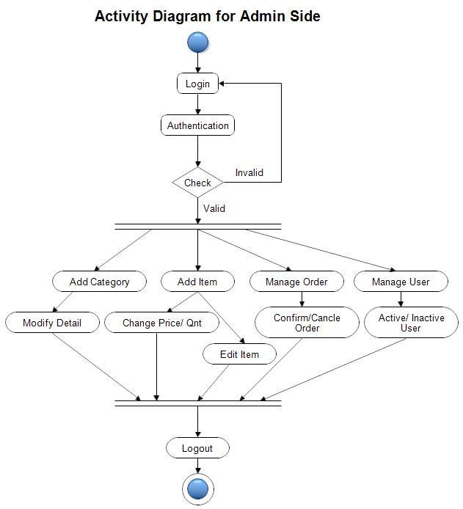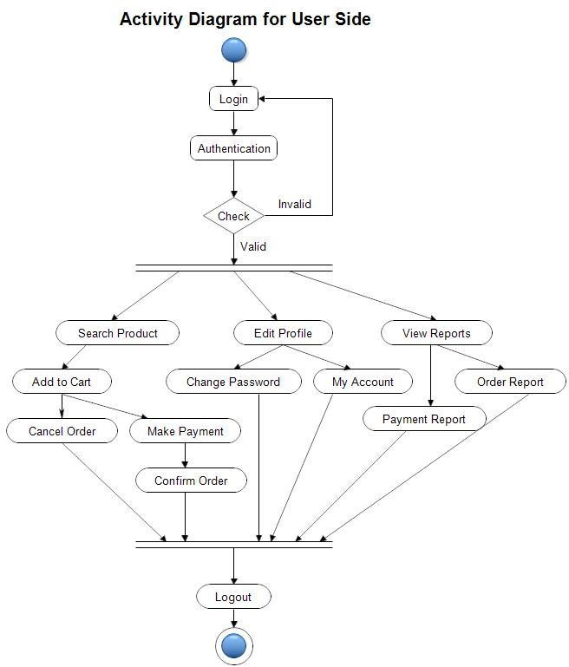

## Data Flow Diagram

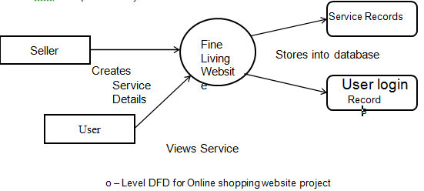

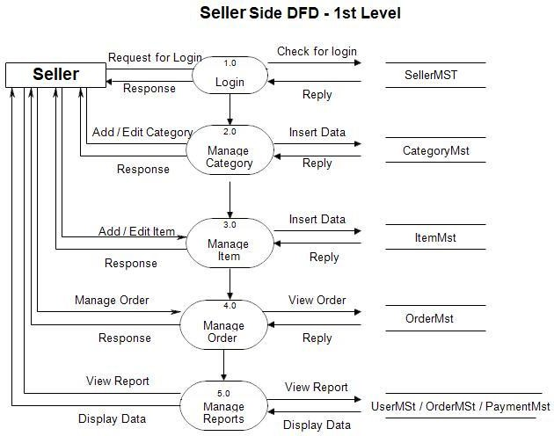

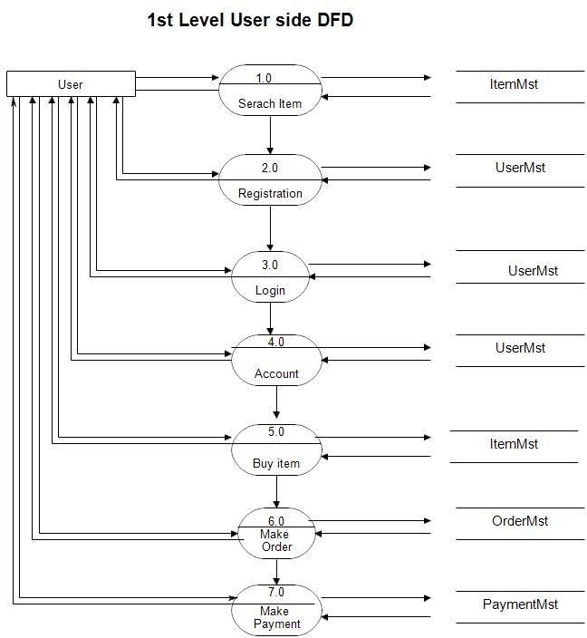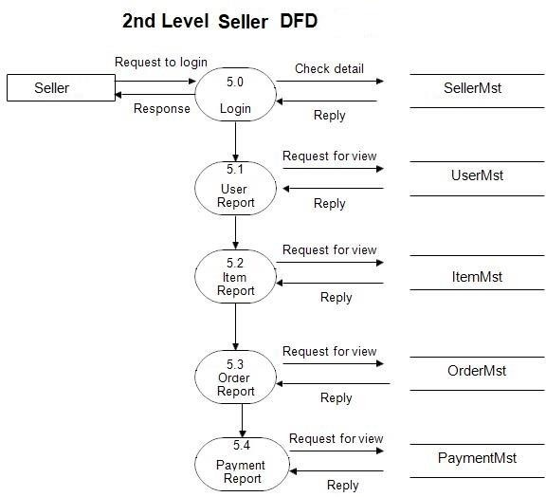

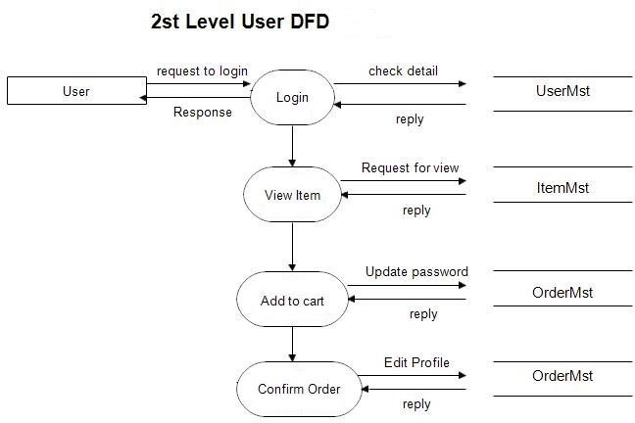

## Class Diagram

## 

## Use Case Diagram

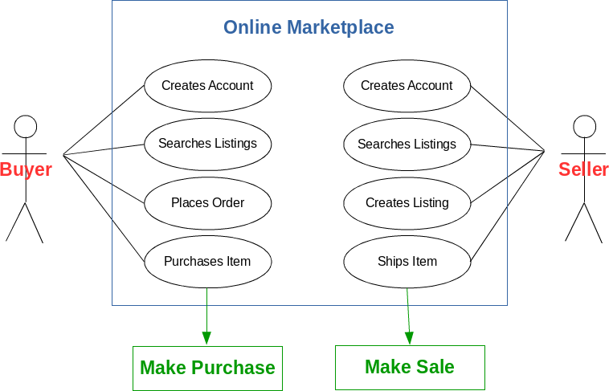

## Sequence Diagram

## User Login Sequence Diagram:

## 

**Buying (Add Service to Shopping Cart) Sequence Diagram:**

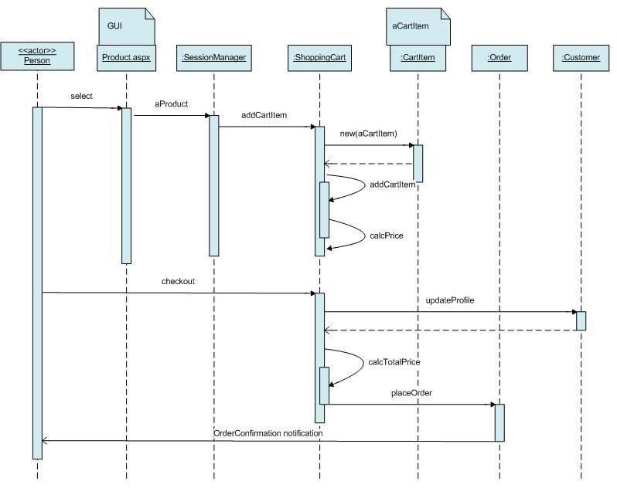

# Table Structure

1. User table

|  |  |  |
| --- | --- | --- |
| **Column name** | **Data type** | **Key constraint** |
| Object id | Varchar(30) | Primary key not null |
| Firstname | Varchar(30 | not null |
| Lastname | Char(20) | Not null |
| Username | Varchar(30) | Not null |
| Email | Varchar(30) | Not null |
| Password | Varchar(30) | Not null |
| Phone | Varchar(30) | Not null |

1. Service Table

|  |  |  |  |
| --- | --- | --- | --- |
| **Column name** | **Data type** | **Key constraints** | **extra** |
| Object id | Varchar(30) | Primary key not null | Auto increment |
| id | int | Foreign key Not null |  |
| URL | Char(100) | Not null |  |
| detailUrl | Char(100) | null |  |
| Title | Char(40) | Not NULL |  |
| Price | Double | Not null |  |
| Quantity | Int | Not null |  |
| Description | Varchar(100) | Not null |  |
| Discount | Varchar |  |  |
| Tagline | varchar |  |  |

**Conclusion**

Fine Living helps in overcoming the issues faced by consumers as well as Service providers by easily making it possible to provide household services to users and give employment opportunities to providers. User can access services and functionalities from home anywhere and anytime for their own comfort.

# Future Scope

E-commerce is a term for any type of business, or commercial transaction that involves the transfer of information across the Internet. It covers a range of different types of businesses, from consumer based retail sites, through auction or music sites, to business exchanges trading goods and services between corporations. It is currently one of the most important aspects of the Internet to emerge.

This web application can be further developed by adding extra functionalities and developing dedicated Mobile Application for consumer as well as seller.

# References

Reference for geeky operating environments [www.w3techs.com](http://www.w3techs.com/)

Reference for user interfaces of e-commerce [www.uianduxdesign.com](http://www.uianduxdesign.com/)

Reference for Fine Living’s Vision and motto [www.wikipedia.com](http://www.wikipedia.com/)

Reference for [https://programformca.com](https://programformca.com/)